Node-RED is a programming tool for wiring together hardware devices, APIs and online services in new and interesting ways.
It provides a browser-based editor that makes it easy to wire together flows using the wide range of nodes in the palette that can be deployed to its runtime in a single-click.

Node-RED

Low-code programming for event-driven applications

Browser-based flow editing
Node-RED provides a browser-based flow editor that makes it easy to wire together flows using the wide range of nodes in the palette. Flows can be then deployed to the runtime in a single-click.
JavaScript functions can be created within the editor using a rich text editor.
A built-in library allows you to save useful functions, templates or flows for re-use.

Built on Node.js
The light-weight runtime is built on Node.js, taking full advantage of its event-driven, non-blocking model. This makes it ideal to run at the edge of the network on low-cost hardware such as the Raspberry Pi as well as in the cloud.
With over 225,000 modules in Node's package repository, it is easy to extend the range of palette nodes to add new capabilities.

Social Development
The flows created in Node-RED are stored using JSON which can be easily imported and exported for sharing with others.
An online flow library allows you to share your best flows with the world.

Get Started
Node-RED is built on Node.js, taking full advantage of its event-driven, non-blocking model. This makes it ideal to run at the edge of the network on low-cost hardware such as the Raspberry Pi as well as in the cloud.
This guide will help you get Node-RED installed and running in just a few minutes.
Pick where you want to run Node-RED, whether on your local computer, a device such as a Raspberry Pi or in the cloud and follow the guides below.
  - Overview
  - 1. Access the editor
  - 2. Add an Inject node
  - 3. Add a Debug node
  - 4. Wire the two together
  - 5. Deploy
  - 6. Inject
  - 7. Add a Function node
  - Summary
  - Source
  - Next Steps
  - Related reading

Creating your first flow

Overview
This tutorial introduces the Node-RED editor and creates a flow that demonstrates the Inject, Debug and Function nodes.

1. Access the editor
With Node-RED running, open the editor in a web browser.
If you are using a browser on the same computer that is running Node-RED, you can access it with the url: http://localhost:1880.
If you are using a browser on another computer, you will need to use the ip address of the computer running Node-RED: http://<ip-address>:1880.

2. Add an Inject node
The Inject node allows you to inject messages into a flow, either by clicking the button on the node, or setting a time interval between injects.
Drag one onto the workspace from the palette.
Select the newly added Inject node to see information about its properties and a description of what it does in the Information sidebar pane.

3. Add a Debug node
The Debug node causes any message to be displayed in the Debug sidebar. By default, it just displays the payload of the message, but it is possible to display the entire message object.

4. Wire the two together
Connect the Inject and Debug nodes together by dragging between the output port of one to the input port of the other.

5. Deploy
At this point, the nodes only exist in the editor and must be deployed to the server.
Click the Deploy button.

6. Inject
With the Debug sidebar tab selected, click the Inject button (the small square button next to your inject node). You should see numbers appear in the sidebar. By default, the Inject node uses the number of milliseconds since January 1st, 1970 as its payload.

7. Add a Function node
The Function node allows you to pass each message though a JavaScript function.
Delete the existing wire (select it and press delete on the keyboard).
Wire a Function node in between the Inject and Debug nodes.
Double-click on the Function node to bring up the edit dialog. Copy the following code into the function field:
// Create a Date object from the payload
var date = new Date(msg.payload);
// Change the payload to be a formatted Date string
msg.payload = date.toString();
// Return the message so it can be sent on
return msg;
Click Done to close the edit dialog and then click the deploy button.
Now when you click the Inject button, the messages in the sidebar will now be formatted is readable timestamps.

Summary
This flow demonstrates the basic concept of creating a flow. It shows how the Inject node can be used to manually trigger a flow, and how the Debug node displays messages in the sidebar. It also shows how the Function node can be used to write custom JavaScript to run against messages.

Source
The flow created in this tutorial is represented by the following json. To import it into the editor, copy it to your clipboard and then paste it into the Import dialog.
[{"id":"58ffae9d.a7005","type":"debug","name":"","active":true,"complete":false,"x":640,"y":200,"wires":[]},{"id":"17626462.e89d9c","type":"inject","name":"","topic":"","payload":"","repeat":"","once":false,"x":240,"y":200,"wires":[["2921667d.d6de9a"]]},{"id":"2921667d.d6de9a","type":"function","name":"Format timestamp","func":"// Create a Date object from the payload\nvar date = new Date(msg.payload);\n// Change the payload to be a formatted Date string\nmsg.payload = date.toString();\n// Return the message so it can be sent on\nreturn msg;","outputs":1,"x":440,"y":200,"wires":[["58ffae9d.a7005"]]}]

  - Overview
  - 1. Add an Inject node
  - 2. Add an HTTP Request node
  - 3. Add a CSV node
  - 4. Add a Debug node
  - 5. Wire them all together
  - 6. Add a Switch node
  - 7. Add a Change node
  - 8. Add a Debug node
  - 9. Deploy
  - Summary
  - Source
  - Related reading

Creating your second flow

Overview
This tutorial builds on the first tutorial to make a flow that starts to bring in data from external sources to do something useful locally.
The flow will:
- Retrieve information from a website at a regular interval
- Convert that information into a useful form
- Display the result in the Debug sidebar

1. Add an Inject node
In the previous tutorial, the Inject node was used to trigger the flow when its button was clicked. For this tutorial, the Inject node will be configured to trigger the flow at a regular interval.
Drag an Inject node onto the workspace from the palette.
Double click the node to bring up the edit dialog. Set the repeat interval to every 5 minutes.
Click Done to close the dialog.

2. Add an HTTP Request node
The HTTP Request node can be used to retrieve a web-page when triggered.
After adding one to the workspace, edit it to set the URL property to:
https://earthquake.usgs.gov/earthquakes/feed/v1.0/summary/significant_month.csv
Then click Done to close the dialog.
This URL is a feed of significant earthquakes in the last month from the US Geological Survey web site. The site offers a number of other options that you may want to play around with after completing this tutorial.

3. Add a CSV node
Add a CSV node and edit its properties. Enable option for ‘First row contains column names’.
Then click Done to close.

4. Add a Debug node
Add a Debug node to the output.

5. Wire them all together
Add wires connecting:
- The Inject node output to the HTTP Request node input.
- The HTTP Request node output to the CSV node input.
- The CSV node output to the Debug node input.

6. Add a Switch node
Add a Switch node to the workspace. Edit its properties and configure it to check the property msg.payload.mag with a test of >= change it to test on a number and the value 7. Click Done to close.
Add a second wire from the CSV node to this Switch node.

7. Add a Change node
Add a Change node, wired to the output of the Switch node. Configure it to set msg.payload to the string PANIC!.

8. Add a Debug node
Wire a new Debug node to the output of the Change node

9. Deploy
Deploy the flow to the runtime by clicking the Deploy button.
With the Debug sidebar tab open click the Inject button. You should see a list of entries with some contents that look like:
msg.payload : Object
{"time":"2017-11-19T15:09:03.120Z","latitude":-21.5167,"longitude":168.5426,"depth":14.19,"mag":6.6,"magType":"mww","gap":21,"dmin":0.478,"rms":0.86,"net":"us","id":"us2000brgk","updated":"2017-11-19T17:10:58.449Z","place":"68km E of Tadine, New Caledonia","type":"earthquake","horizontalError":6.2,"depthError":2.8,"magError":0.037,"magNst":72,"status":"reviewed","locationSource":"us","magSource":"us"}
You can now click on the little arrow to the left of each property to expand them and examine the contents
If there were any quakes with a magnitude greater than 7 you will also see debug messages like:
msg.payload : string(6)
"PANIC!"
You could change the switch value of 7 to a smaller one to test your program. Remember to click on deploy after the change. ***

Summary
This flow is automatically triggered every 5 minutes and retrieves data from a url. It parses the data and displays in the Debug sidebar. It also checks the magnitude value in the data and branches the flow for any messages with a magnitude greater than, or equal to, 7. The payloads of such messages are modified and displayed in the Debug sidebar.

Source
The flow created in this tutorial is represented by the following json. To import it into the editor, copy it to your clipboard and then paste it into the Import dialog.
[{"id":"e36406f2.8ef798","type":"inject","z":"f03b57d5.e525f8","name":"","topic":"","payload":"","payloadType":"str","repeat":"300","crontab":"","once":false,"x":130,"y":900,"wires":[["c3c50023.3bbed"]]},{"id":"c3c50023.3bbed","type":"http request","z":"f03b57d5.e525f8","name":"Recent Quakes","method":"GET","url":"https://earthquake.usgs.gov/earthquakes/feed/v1.0/summary/significant_month.csv","tls":"","x":300,"y":900,"wires":[["8afc6cac.e0812"]]},{"id":"8afc6cac.e0812","type":"csv","z":"f03b57d5.e525f8","name":"","sep":",","hdrin":true,"hdrout":"","multi":"one","ret":"\\n","temp":"","x":470,"y":900,"wires":[["44779781.4190f8","6f0eb546.9e208c"]]},{"id":"44779781.4190f8","type":"debug","z":"f03b57d5.e525f8","name":"","active":true,"complete":false,"x":630,"y":900,"wires":[]},{"id":"6f0eb546.9e208c","type":"switch","z":"f03b57d5.e525f8","name":"","property":"payload.mag","propertyType":"msg","rules":[{"t":"gte","v":"7","vt":"num"}],"checkall":"true","outputs":1,"x":510,"y":960,"wires":[["d78d4aa8.8c8208"]]},{"id":"d78d4aa8.8c8208","type":"change","z":"f03b57d5.e525f8","name":"","rules":[{"t":"set","p":"payload","pt":"msg","to":"PANIC!","tot":"str"}],"action":"","property":"","from":"","to":"","reg":false,"x":650,"y":1020,"wires":[["72fddece.fac0d"]]},{"id":"72fddece.fac0d","type":"debug","z":"f03b57d5.e525f8","name":"","active":true,"complete":false,"x":750,"y":960,"wires":[]}]
The editor window consists of four components:
- The header at the top, containing the deploy button, main menu, and, if user authentication is enabled, the user menu.
- The palette on the left, containing the nodes available to use.
- The main workspace in the middle, where flows are created.
- The sidebar on the right.
Follow the links above to learn more about each component.
  - ditor Guide
  - Workspace
  - Flows
    - Adding a flow
    - Reordering flows
    - Editing flow properties
    - Enabling or disabling a flow
    - Hiding or showing a flow
    - Locking a flow
    - Deleting a flow
    - Switching between flows
  - Nodes
  - Wires
  - Groups
  - Subflows
  - Selection
  - Arranging Nodes
  - Import/Export
  - Search
  - Palette
  - Palette Manager
  - Sidebar
  - Information
  - Help
  - Debug
  - Config nodes
  - Context data

Flows
A flow is represented as a tab within the editor workspace and is the main way to organise nodes.
Flow tabs
Note : The term "flow" is also used to informally describe a single set of connected nodes. So a flow (tab) can contain multiple flows (sets of connected nodes).
Each flow can have a name, and description that is displayed in the Information sidebar.
All of the nodes in a flow can access the same flow-scoped context.

Adding a flow
To add a new flow, either click the button in the top bar, or double-click on free space in the tab bar.
Reference
Key shortcut | none
Menu option | Flows -> Add
Action | core:add-flow

Reordering flows
Flows can be reordered in the workspace by dragging their tabs around in the tab bar.

Editing flow properties
To edit a flow’s properties, double-click on its tab in the top bar. This will open the Flow Properties dialog.
- : Properties - set the flow's name and description. The description can use Markdown syntax for formatting and will appear in the Information sidebar.
- : Environment Variables - properties that are exposed as environment variables within the flow. Since Node-RED 2.1
Reference
Key shortcut | none
Menu option | Flows -> Rename
Action | core:edit-flow

Enabling or disabling a flow
The flow can be enabled or disabled using the toggle button at the bottom of the dialog. If a flow is disabled, none of the nodes it contains will be created when the flow is deployed.
The button in the Information sidebar can also be used to enable or disable the node/flow.
Reference
Key shortcut | none
Menu option | none
Action | core:enable-flow
Reference
Key shortcut | none
Menu option | none
Action | core:disable-flow

Hiding or showing a flow
A flow can be hidden by right-clicking on it and selecting ‘hide flow’ in the context menu. The option can also be found in the tab bar drop-down menu.
When hidden, the Information sidebar will show an icon next to it. Clicking that icon will show the flow again.
Reference
Key shortcut | Alt-w
Menu option | [Tab Menu] Hide flow
Action | core:hide-flow
Reference
Key shortcut | Alt-Shift-w
Menu option | [Tab Menu] Show last hidden flow
Action | core:show-last-hidden-flow
Reference
Key shortcut | none
Menu option | [Tab Menu] Hide other flows
Action | core:hide-other-flows
Reference
Key shortcut | none
Menu option | [Tab Menu] Hide all flows
Action | core:hide-all-flows
Reference
Key shortcut | none
Menu option | [Tab Menu] Show all flows
Action | core:show-all-flows

Locking a flow
Flows can be locked to prevent any changes being made to them.
To lock/unlock a flow, you can:
- Right-click on its tab and select the ‘lock flow’ option
- Toggle the lock button in the bottom corner of the Flow Properties dialog
- Click the padlock icon in the Information Sidebar when hovering over the flow
Reference
Key shortcut | none
Menu option | [Tab Menu] Lock Flow
Action | core:lock-flow
Reference
Key shortcut | none
Menu option | [Tab Menu] Unlock Flow
Action | core:unlock-flow

Deleting a flow
To delete a flow, click the ‘Delete’ button in the Flow Properties dialog.
Reference
Key shortcut | none
Menu option | Flows -> Delete
Action | core:remove-flow

Switching between flows
To open a list of the available flows, click the menu button in the top bar. Then select the List Flows option.
Reference
Key shortcut | Ctrl/⌘-Shift-f
Menu option | none
Action | core:list-flows
Reference
Key shortcut | Ctrl/⌘-[
Menu option | none
Action | core:show-previous-tab
Reference
Key shortcut | Ctrl/⌘-]
Menu option | none
Action | core:show-next-tab

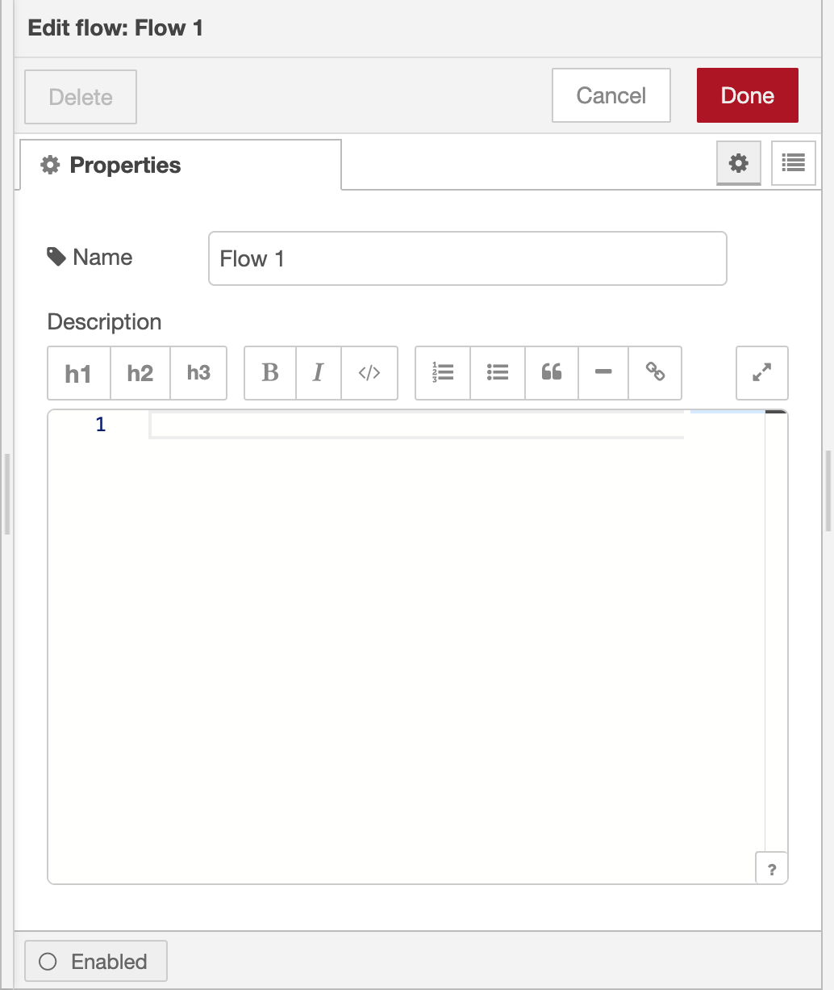
Flow properties editor
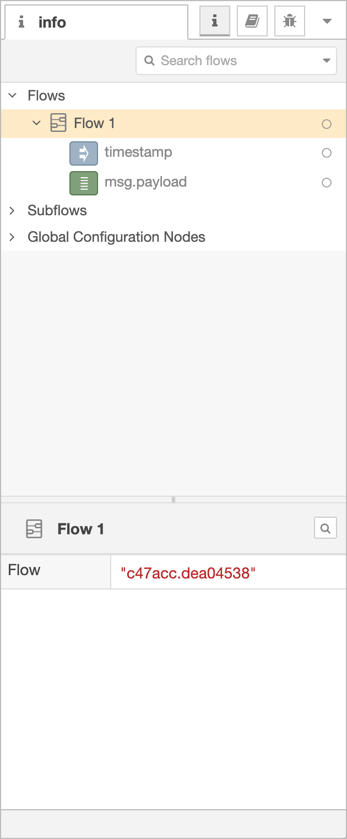
Information Sidebar
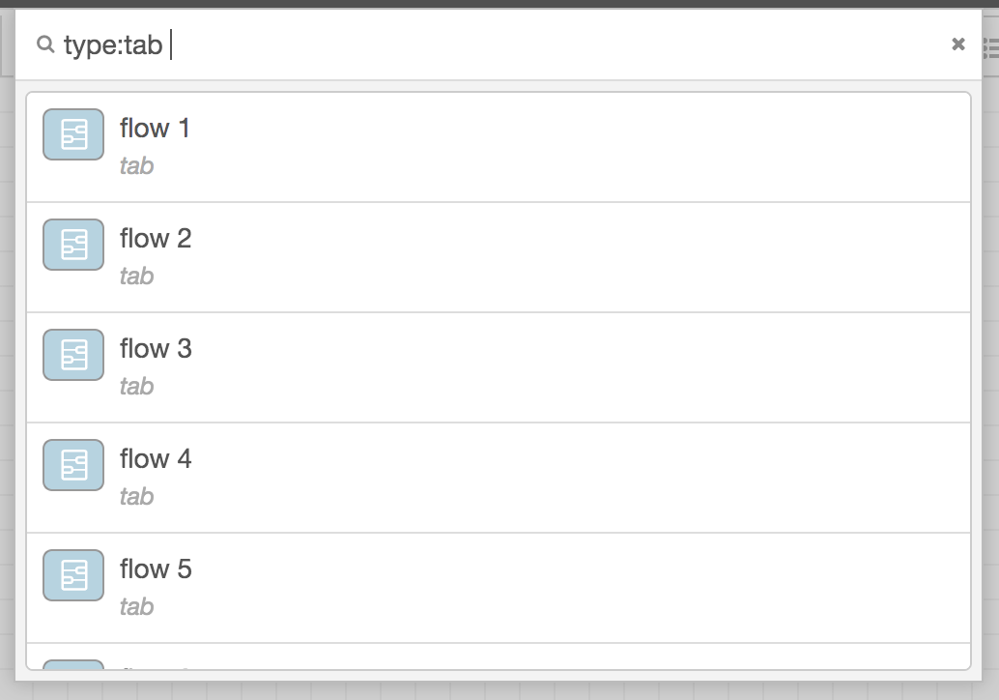
Search flows

Nodes
Nodes can be added to the workspace by either:
- dragging them from the palette,
- using the quick-add dialog,
- or importing from the library or clipboard.
Nodes are joined together by wires via their ports. A node can have at most one input port and many output ports. A port may have a label that is displayed when the mouse hovers over it. A node may specify labels, for example, the Switch node shows the rule that matches the port. The labels can also be customised in the node edit dialog.
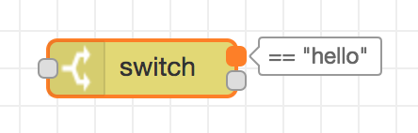
Node port labels
Some nodes display a status message and icon below the node. This is used to indicate the runtime state of the node - for example, the MQTT nodes indicate if they are currently connected or not.
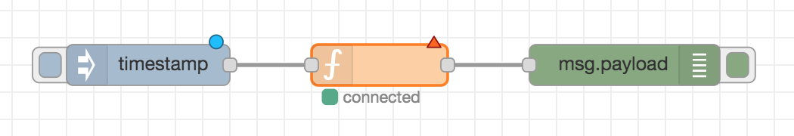
Node elements
If a node has any undeployed changes, it displays a blue circle above it. If there are errors with its configuration, it displays a red triangle.
Some nodes include a button on either its left or right edge. These allow some interaction with the node from within the editor. The Inject and Debug nodes are the only core nodes that have buttons.

Quick-Add dialog
The Quick-Add dialog provides an easy way to add a node to the workspace wherever the mouse is, without having to drag it over from the palette.
The dialog is opened by holding the Ctrl or Command key when clicking on the workspace.
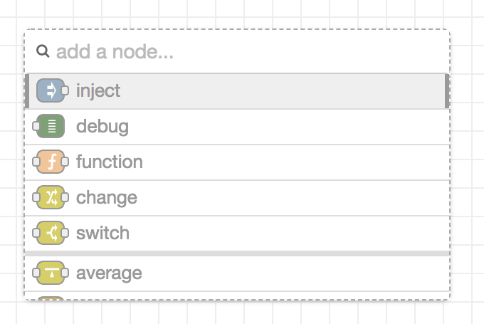
Quick-Add dialog
The dialog contains a complete list of all nodes available to add. It shows the five main core nodes at the top of the list, followed by any recently added nodes and finally a complete, alphabetical, list of the remaining nodes.
As with the main palette, the dialog has an input at the top to filter the list and quickly find a node.
If Ctrl or Command is kept held down when clicking on a node in the list, the node will be added and the Quick-Add dialog kept open to add the next node in the flow.
If a wire is clicked on when triggering the dialog, the added node will be spliced into the wire.

Editing node properties
A node’s configuration can be edited by double clicking on the node, or pressing Enter when the workspace has focus. If multiple nodes are selected, the first node in the selection will be edited.
The edit dialog contains three tabs:
- : Properties - the edit form specific to the node type being edited.
- : Description - per-node documentation formatted using Markdown. This is displayed in the Information sidebar when the node is selected.
- : Appearance - options to customise the appearance of the node.
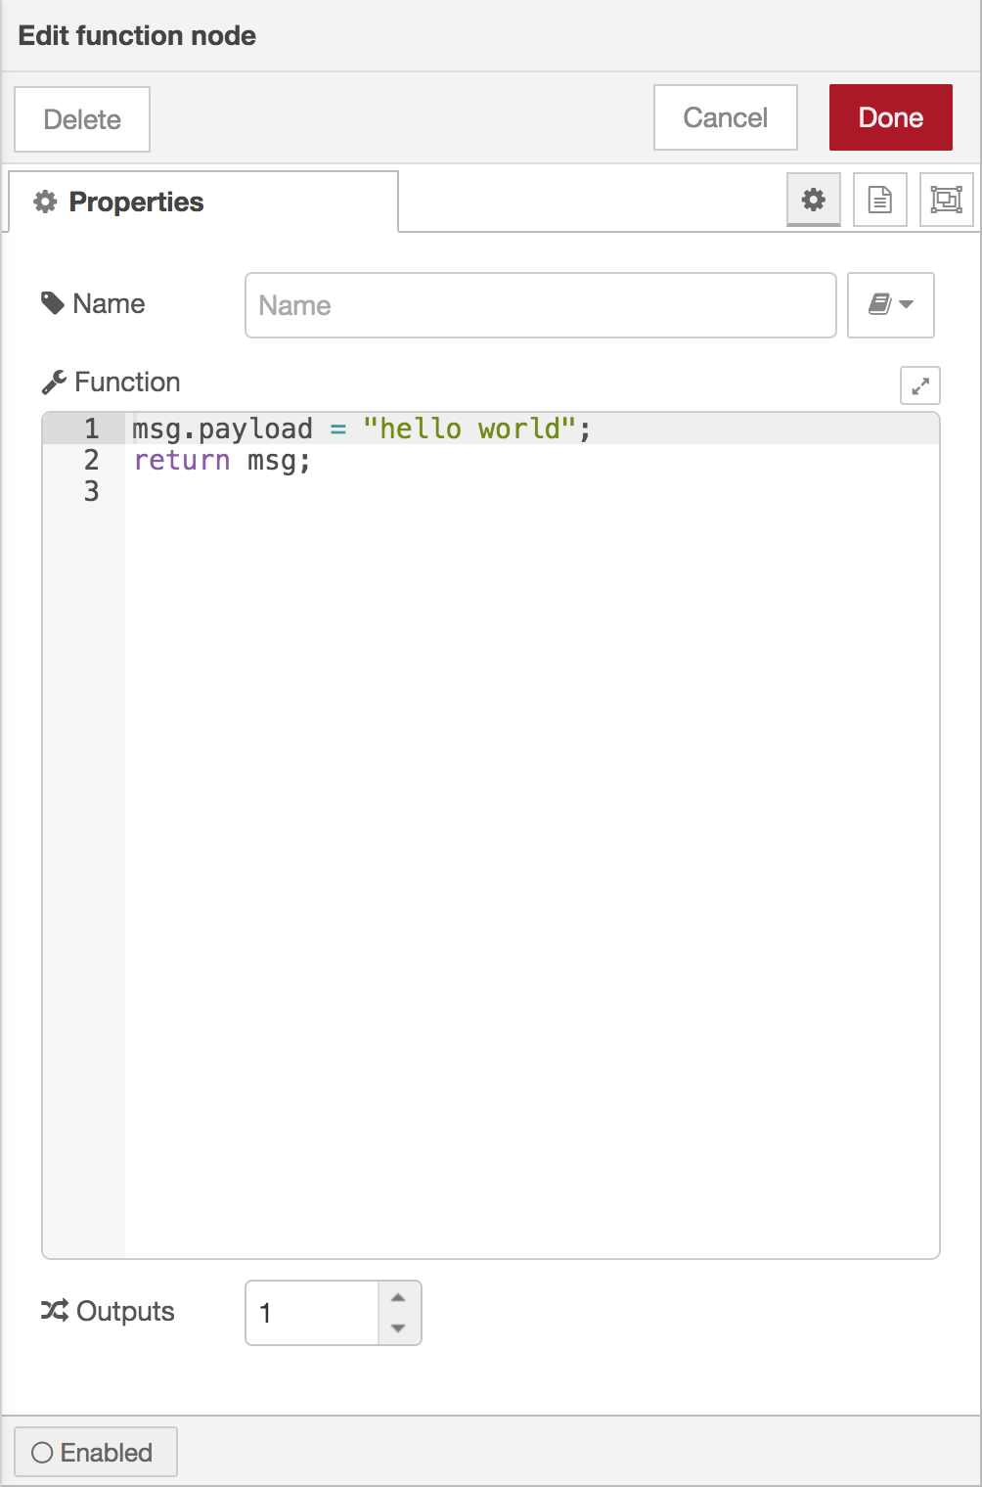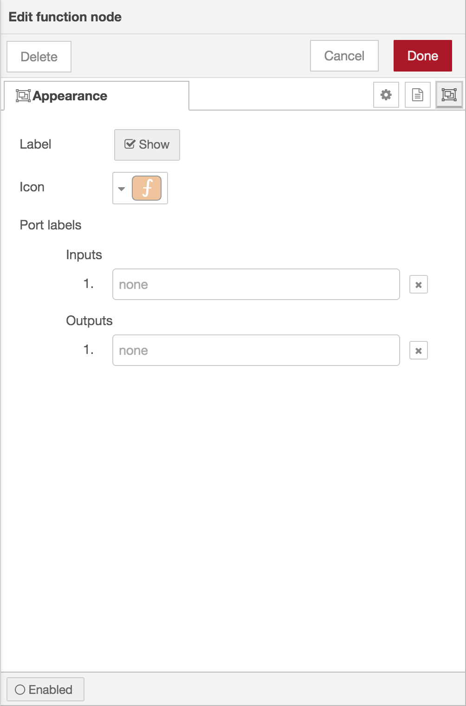
Node edit dialog - properties, description and appearance tabs
The Appearance tab provides options to:
Reference
Action | core:show-selected-node-labels
Reference
Action | core:hide-selected-node-labels

- select whether the node’s label is shown
- change the icon of the node
- provide custom port labels.

Enabling or disabling a node
An node can be enabled or disabled using the toggle button at the bottom of the dialog. If a node is disabled it will not be created when the flow is deployed. If a disabled node sits in the middle of a flow, no messages will pass through it.
Reference
Action | core:enable-selected-nodes
Reference
Action | core:disable-selected-nodes

Configuration nodes
A Configuration (config) Node is a special type of node that holds reusable configuration that can be shared by regular nodes in a flow.
For example, the MQTT In and Out nodes use an MQTT Broker config node to represent a shared connection to an MQTT broker.
Configuration nodes are added through the edit dialog of a node that requires the config node. It will have a field to select from the available config nodes of the required type or to add a new instance.
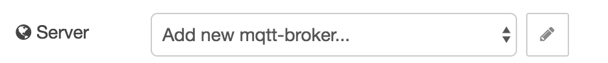
Adding a configuration node
Clicking the button next to the select box will open the edit dialog for the selected node, or add a new instance.
The config node edit dialog only has the node properties and description tabs - as a config node has no icon or ports to set labels on.
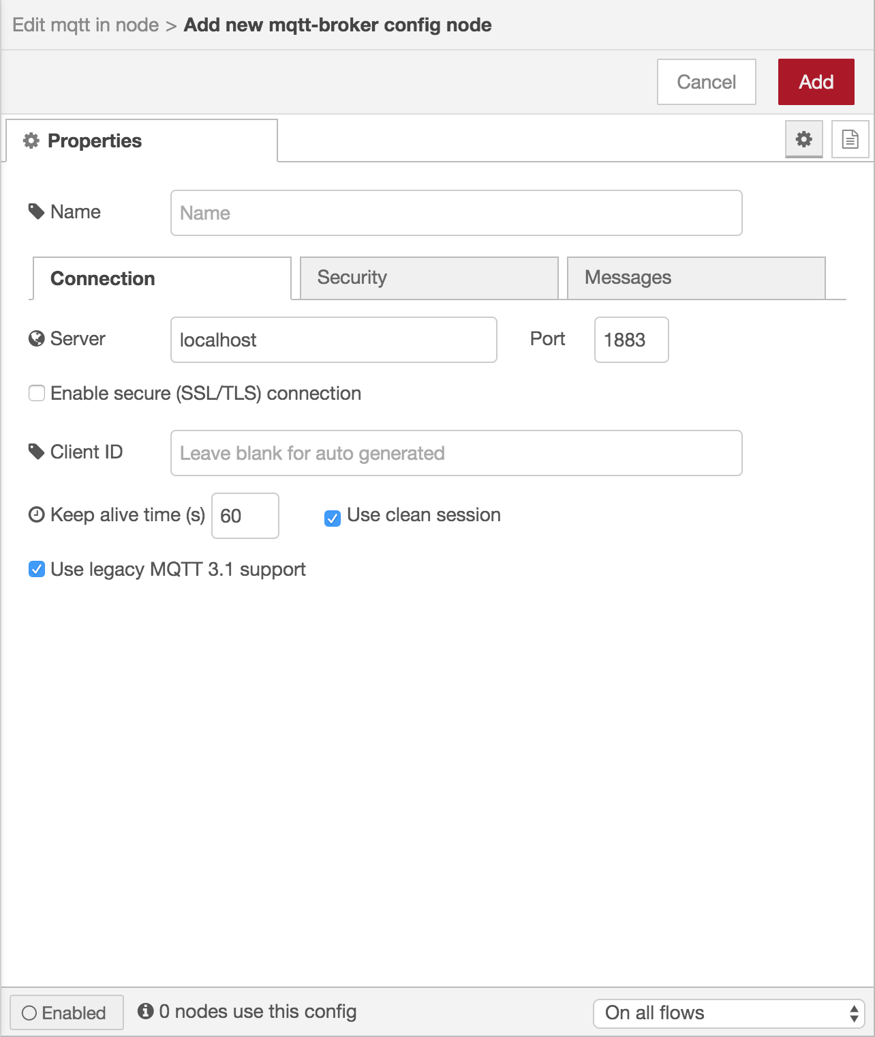
Configuration node edit dialog
In the footer of the dialog is an indication of how many nodes use this config node. It also provides a select box to set the scope of the config node. The scope determines which flows the config node is available on. By default it is available on all flows, but the select box can be used to make it local to just one flow.
As with normal nodes, it can also be enabled or disabled using the toggle button in the footer.
The Configuration Nodes Sidebar can be used to manage all config nodes

  - Editor Guide
  - Workspace
  - Flows
  - Nodes
  - Wires
    - Splitting wires
    - Moving wires
    - Selecting multiple wires
    - Deleting wires
    - Slicing wires
    - Detaching nodes
  - Groups
  - Subflows
  - Selection
  - Arranging Nodes
  - Import/Export
  - Search
  - Palette
  - Palette Manager
  - Sidebar
  - Information
  - Help
  - Debug
  - Config nodes
  - Context data

Wires
Nodes are wired together by pressing the left-mouse button on a node’s port, dragging to the destination node and releasing the mouse button.
Alternatively, if the Ctrl/Command key is held down, the left-mouse button can be clicked (and released) on a node’s port and then clicked on the destination. If the Ctrl/Command key remains held and the just-wired destination node has an output port, a new wire is started from that port. This allows a set of nodes to be quickly wired together.
This can also be combined with the Quick-Add dialog that is triggered by a Ctrl/Command-Click on the workspace to quickly insert new nodes and have them already wired to previous nodes in the flow.

Splitting wires
If a node with both an input and output port is dragged over the mid-point of a wire, the wire is draw with a dash. If the node is then dropped, it is automatically inserted into the flow at that point.
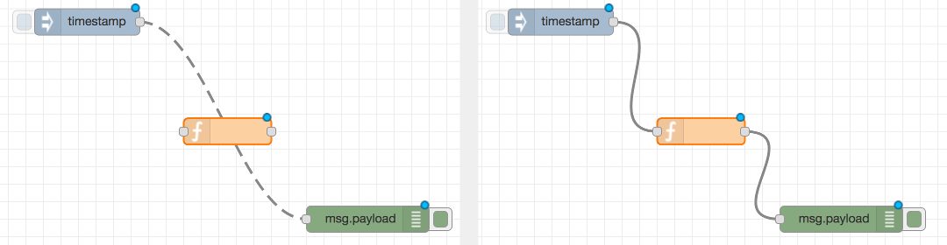
Dropping a node on a wire to insert it mid-flow

Moving wires
To disconnect a wire from a port, select the wire by clicking on it, then press and hold the Shift key when the left-mouse button is pressed on the port. When the mouse is then dragged, the wire disconnects from the port and can be dropped on another port. If the mouse button is released over the workspace, the wire is deleted.
If a port has multiple wires connected to it, if none of them is selected when button is pressed with the Shift key held, all of the wires will move.

Selecting multiple wires
You can also select multiple wires by holding Ctrl/Command while clicking on them.
When you select multiple nodes, we also highlight any wires between them. This can make it easier to follow a flow once you have selected it.
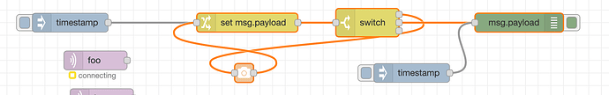
Selecting multiple wires

Deleting wires
- Select one or more wires
  - To select a single wire, left click 1 wire.
  - To select multiple wires, left click 1 wire then while holding Ctrl/Command, click on the other wires.
- Press the Delete key

Slicing wires
You can also remove wires by slicing through them. You do this by pressing and holding the Alt/Option key, then dragging with the left-mouse button pressed:
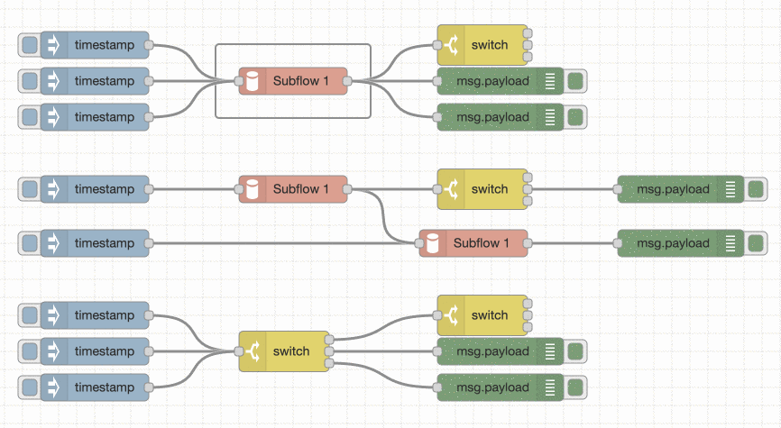
Slicing wires

Detaching nodes

Delete Node, keep wires
You can delete a node from the middle of a flow and have the wiring automatically repair itself in the background:
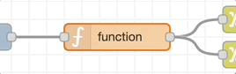
Delete Node, keep wires
Reference
Action | core:core:delete-selection-and-reconnect
Key shortcut | Ctrl/⌘-delete

Detach Node from wires
You can also detach a node from the flow without deleting it:
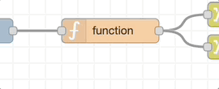
Detach Node from wires
Reference
Action | core:detach-selected-nodes
Key shortcut | *Not assigned
* There is no default shortcut for Detach Node from wires, but you can assign one yourself in the Keyboard pane of the Settings dialog.
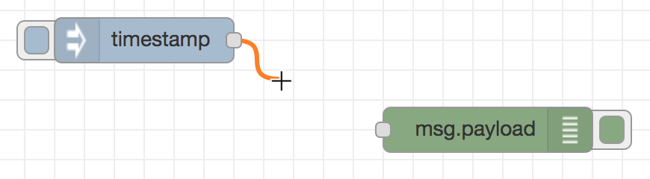
Wiring nodes

Groups
Since Node-RED 1.1.0
Nodes can be joined together to form a group. They can then be moved or copied as a single object within the editor.
Groups can be given a border and background colour, as well as an optional label.
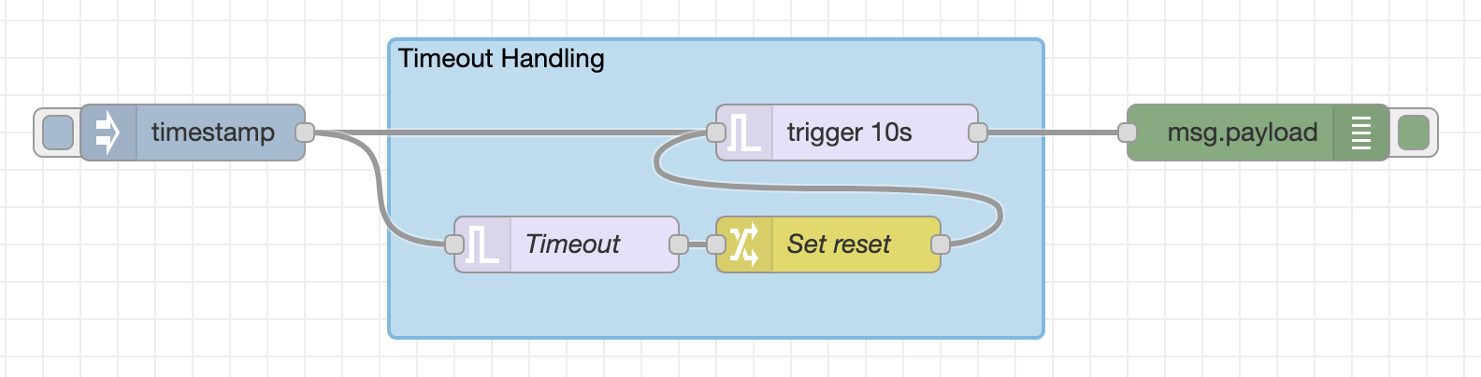
Groups

Creating a group
To create a group, select the nodes and then select the ‘Groups -> Group selection’ option in the menu.
Reference
Key shortcut | Ctrl/⌘-Shift-g
Menu option | Groups -> Group selection
Action | core:group-selection

Editing group properties
A groups’s properties can be edited by double clicking on the group, or pressing Enter when the workspace has focus and the group is selected.
The edit dialog contains two tabs:
- : Properties - the groups properties to edit.
- : Environment Variables - properties that are exposed as environment variables within the group. Since Node-RED 2.1
- : Description - per-node documentation formatted using Markdown. This is displayed in the Information sidebar when the group is selected.
  - Editor Guide
  - Workspace
  - Flows
  - Nodes
  - Wires
  - Groups
  - Subflows
    - Creating an empty subflow
    - Converting nodes to a subflow
    - Editing a subflow
    - Inputs & Outputs
    - Status node
    - Editing subflow properties
    - Deleting a subflow
  - Selection
  - Arranging Nodes
  - Import/Export
  - Search
  - Palette
  - Palette Manager
  - Sidebar
  - Information
  - Help
  - Debug
  - Config nodes
  - Context data

Subflows
A subflow is a collection of nodes that are collapsed into a single node in the workspace.
They can be used to reduce some visual complexity of a flow, or to package up a group of nodes as a reusable flow used in multiple places.
Once created, the subflow is added to the palette of available nodes. Individual instances of the subflow can then be added to the workspace just like any other node.
Note: a subflow cannot contain an instance of itself - either directly or indirectly.

Creating an empty subflow
A subflow can be created by selecting the ‘Subflow -> Create subflow’ option in the menu. This will create a blank subflow and open it in the workspace.
Reference
Key shortcut | none
Menu option | Subflows -> Create subflow
Action | core:create-subflow

Converting nodes to a subflow
It is also possible to convert the current selection of nodes to a subflow by selecting the ‘Subflow -> Selection to Subflow’ option in the menu. The nodes will be moved to a new subflow and replaced by a subflow instance node within the flow.
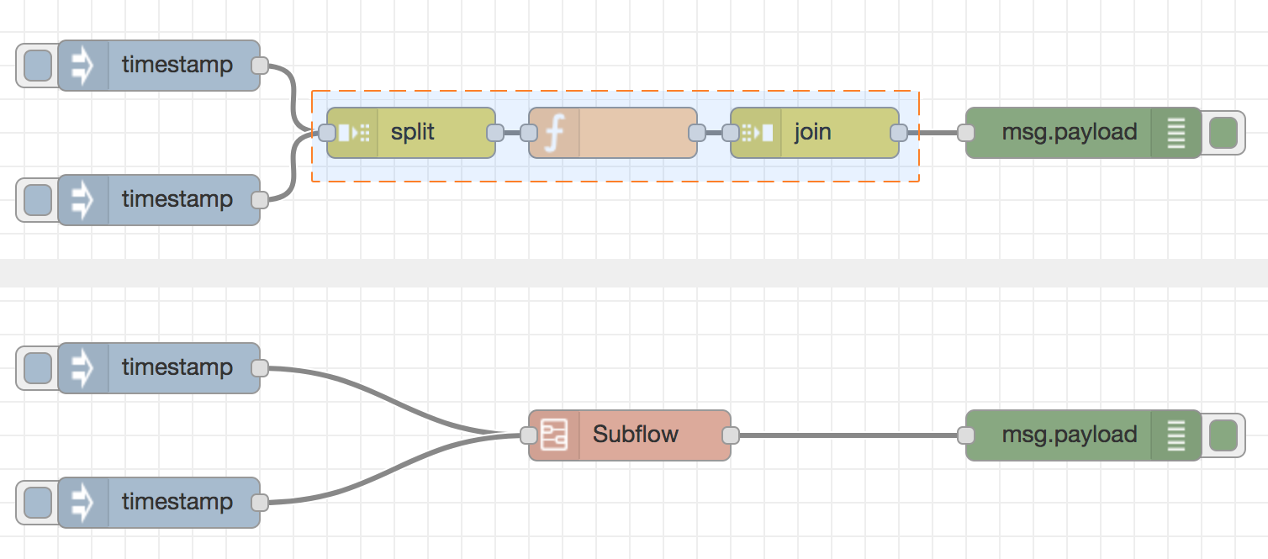
Creating a subflow
This is only possible if any wires coming into the selection are connected to one node - as the resulting subflow node can itself only have at most one input.

Reference
Key shortcut | none
Menu option | Subflows -> Selection to Subflow
Action | core:convert-to-subflow

Editing a subflow
There are two ways to open a subflow to edit its contents. Either double click its node in the palette, or click the ‘Edit flow template’ button in the edit dialog of a subflow instance node.
The subflow is opened in the workspace as a new tab. Unlike regular flow tabs, subflow tabs can be closed to hide them.
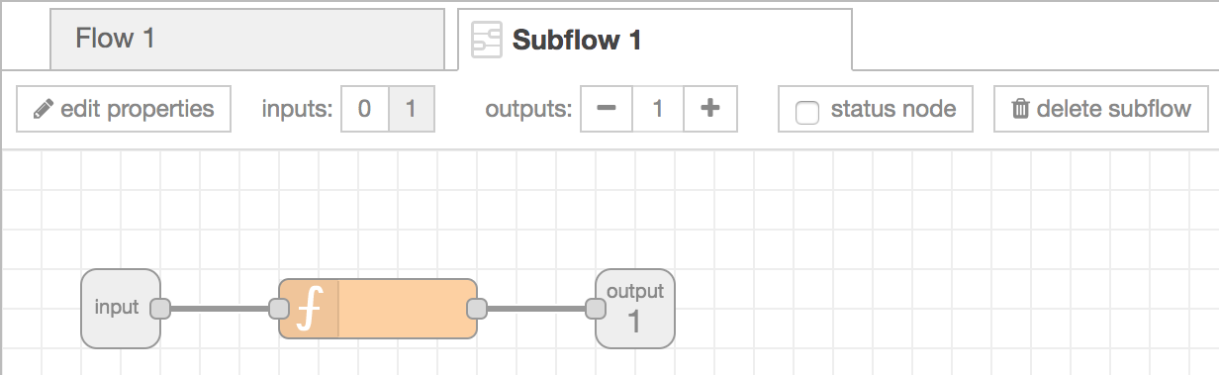
Editing a subflow

Inputs & Outputs
The inputs and outputs of the subflow are represented by the grey square nodes that can be wired into the flow as normal.
The toolbar provides options to add and remove these nodes. As with normal flows nodes, there can be at most one input and as many outputs as needed.

Status node
The toolbar provides an option to add a ‘status’ output to a subflow. This can be used to update the Status of subflow instance nodes.

Editing subflow properties
The ‘edit properties’ button opens the subflow properties dialog. As with the Flow properties dialog, the name and description of the subflow can be set.
- : Properties - per-instance properties that are exposed as environment variables within the subflow.
- : Module Properties - metadata about the subflow. Since Node-RED 1.3
- : Description - per-node documentation formatted using Markdown. This is displayed in the Information sidebar when the node is selected.
- : Appearance - options to customise the appearance of the node.
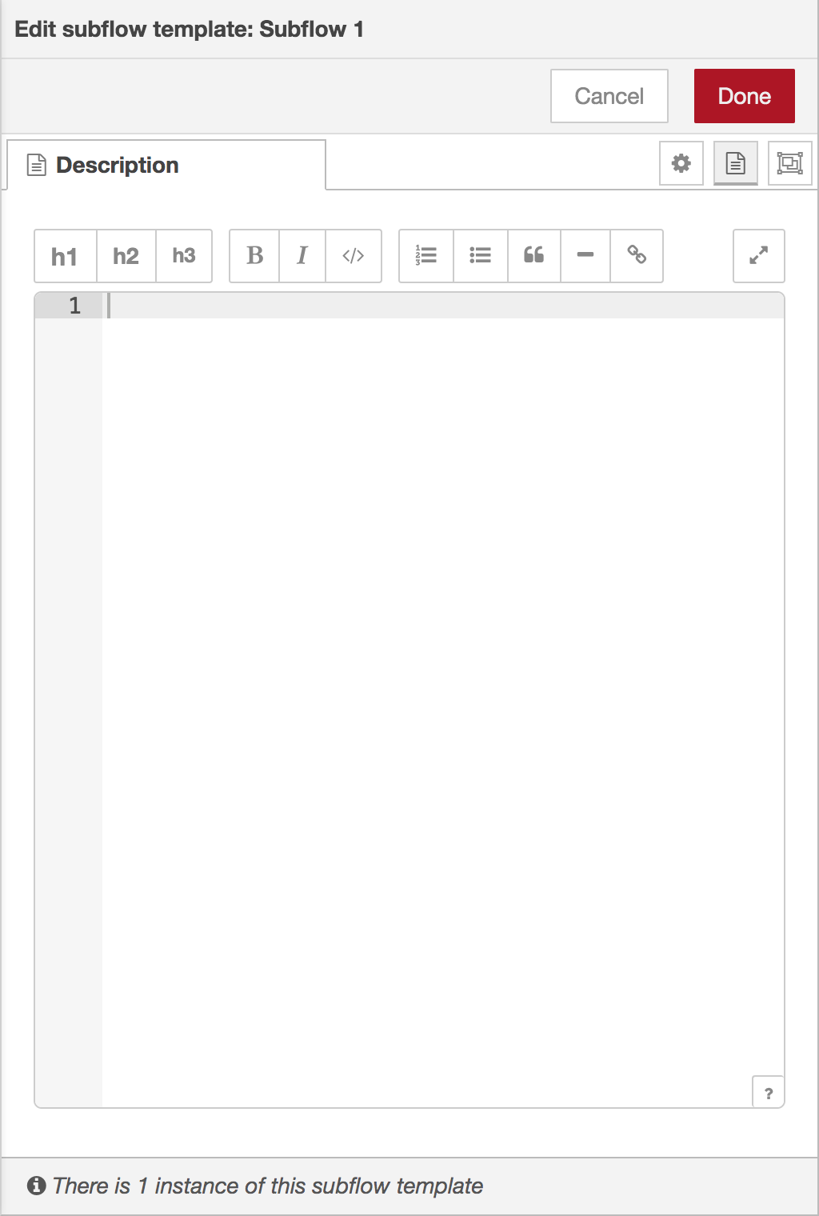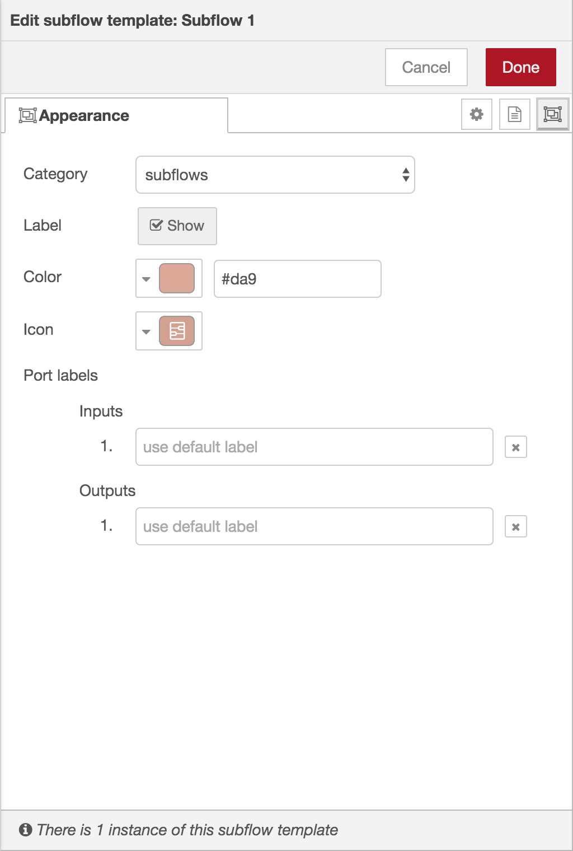
Subflow edit dialog - properties, module properties, description and appearance tabs

Properties
The ‘Properties’ tab of the edit dialog can be used to define a set of properties that can then be customised for each instance of the subflow. The properties are then exposed as environment variables within the subflow.
Each entry in the properties table can be expanded to customise how it is displayed when an instance of the subflow is edited. The ‘UI Preview’ tab provides a preview of how they will appear.

Module Properties
The Module Properties tab can be used to set additional meta-data about the Subflow, including version, license and module name. These can be used when packaging the Subflow as an npm module.

Appearance
The Appearance tab provides options to:
- change the palette category the node appears in
- select whether the node’s label is shown
- change the colour of the node
- change the icon of the node
- provide custom port labels.

Deleting a subflow
The ‘delete subflow’ button in the subflow toolbar can be used to remove the subflow and all instances of it.

Invalid subflow selection
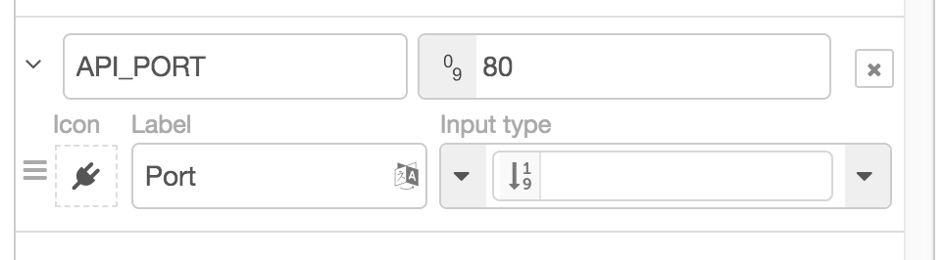
Editing subflow property UI

Editing subflow properties
  - Workspace
  - Flows
  - Nodes
  - Wires
  - Groups
  - Subflows
  - Selection
    - Lasso Tool
    - Selecting all nodes
    - Selecting connected nodes
    - Selecting Upstream or Downstream nodes
    - Selecting flows
    - Editor clipboard
  - Arranging Nodes
  - Import/Export
  - Search
  - Palette
  - Palette Manager
  - Sidebar
  - Information
  - Help
  - Debug
  - Config nodes
  - Context data

Selection
A node is selected when it is clicked on. This will deselect anything currently selected. The Information Sidebar will update to show the node’s properties and help text for its type.
If the Ctrl or Command key is held when clicking on the node, the node will be added to the current selection (or removed if it was already selected).
If the Shift key is held when clicking on the middle of the node, it will select that node and all other nodes it is connected to. Clicking on the left-hand side of the node, it will select that node and all nodes that come before it in the flow - “upstream” nodes. Clicking on the right-hand side of the node, it will select that node and all nodes that come after it in the flow - “downstream” nodes.
A wire is selected when it is clicked on. Unlike nodes, it is only possible to select one wire at a time.

Lasso Tool
The lasso tool can be used to select multiple nodes. It is enabled by click-dragging on the workspace.
It cannot be used to select a wire.

Selecting all nodes
To select all nodes on the current flow, ensure the workspace has focus and then press Ctrl/Command-a.
Reference
Key shortcut | Ctrl/⌘-a
Menu option | Edit -> Select all
Action | core:select-all-nodes

Selecting connected nodes
To select all nodes connected to a particular node, click on the middle of the node whilst holding the Shift key.
Reference
Key shortcut | Alt-s c
Menu option | Edit -> Select all
Action | core:select-connected-nodes

Selecting Upstream or Downstream nodes
To select a node and all of its upstream or downstream nodes, click the left or right side of the node whilst holding the Shift key.
Reference
Key shortcut | Alt-s u
Action | core:select-upstream-nodes
Reference
Key shortcut | Alt-s d
Action | core:select-downstream-nodes

Selecting flows
It is possible to select multiple flows in the editor by holding the Ctrl/Command key when clicking on its tab.
Once selected, they can be deleted, copied or exported just like any selection
Reference
Action | core:select-connected-nodes
Key shortcut | Alt-s c
Reference
Action | core:select-upstream-nodes
Key shortcut | Alt-s u
Reference
Action | core:select-downstream-nodes
Key shortcut | Alt-s d

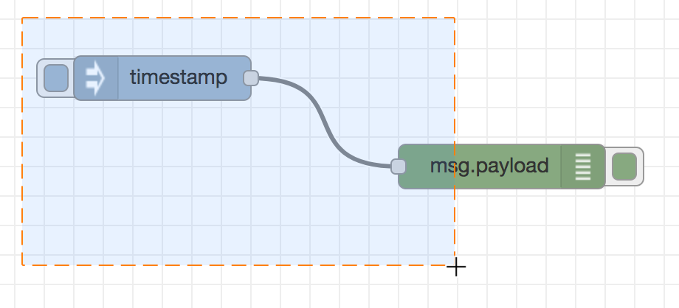
Selecting multiple nodes with the lasso tool

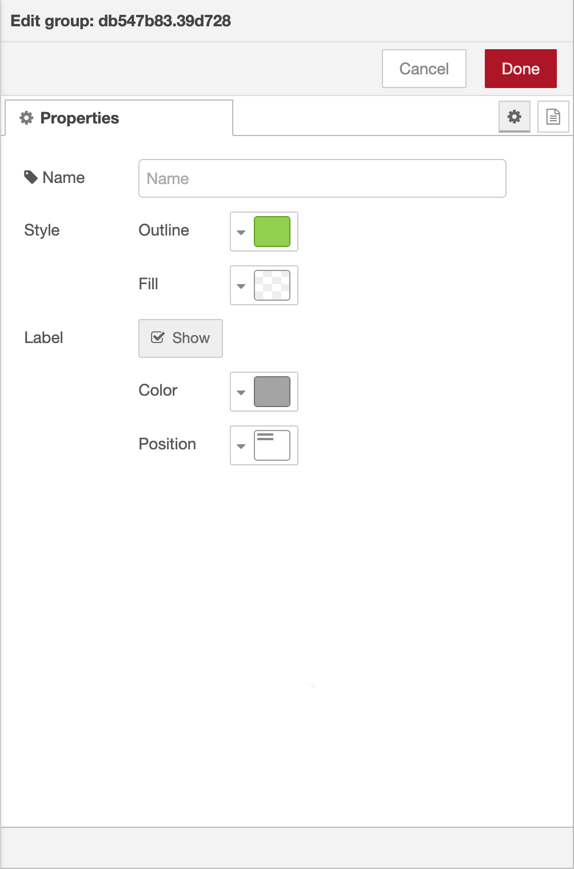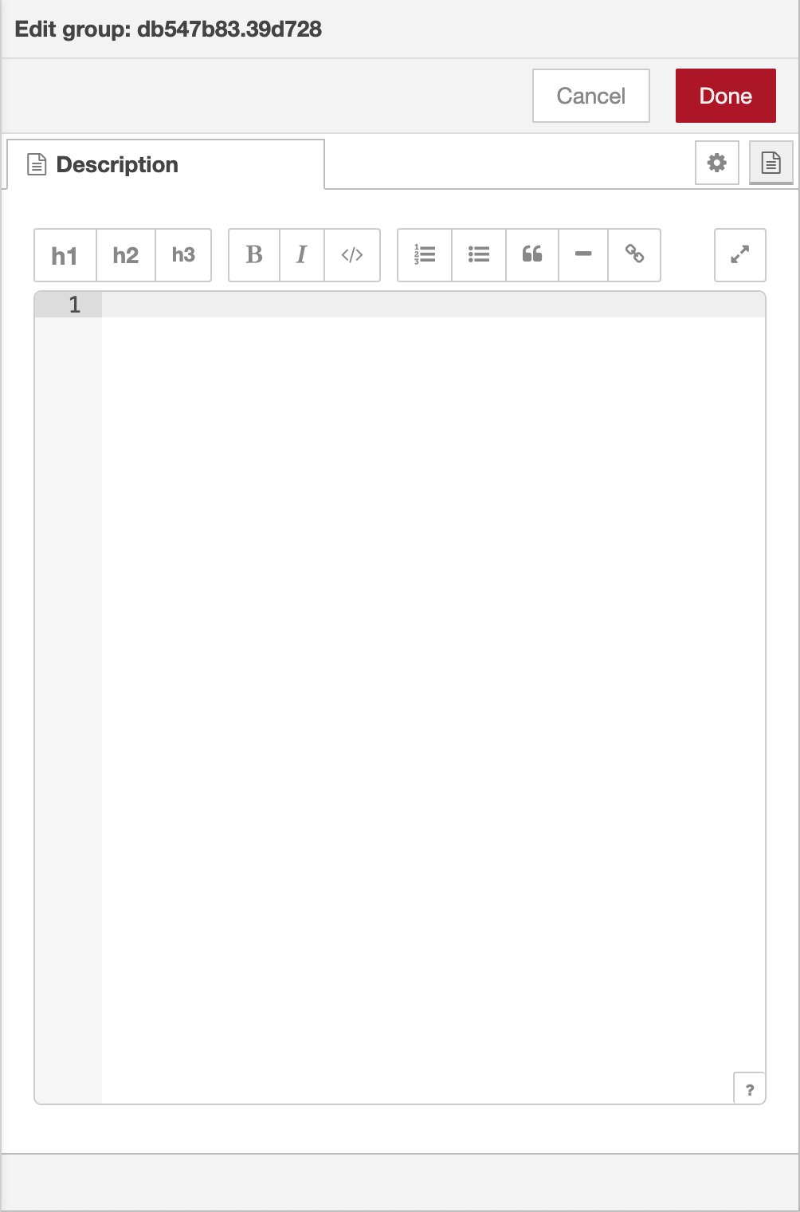
Group edit dialog - properties and description tabs
The Group properties tab provides options to:
- set the outline and fill colours of the group
- select whether the name of the group should be shown as a label, and if so, what colour text to use and where the label should be placed.

Reusing a group’s style
To copy an existing group’s style (outline, fill, color and label position), select the group, then press Ctrl/⌘-Shift-c.
Reference
Key shortcut | Ctrl/⌘-Shift-c
Action | core:copy-group-style
Reference
Key shortcut | Ctrl/⌘-Shift-v
Action | core:paste-group-style

To apply that style to another group, select the group and press Ctrl/⌘-Shift-v.

Adding nodes to a group
Nodes can be added to an existing group by dragging them into the group. Before Node-RED 3.1, this could only be done one node at a time. Since Node-RED 3.1, a whole selection of nodes/groups can be dragged into a group in one go.

Removing from a group
To remove a node from a group, select the node then select the ‘Groups -> Remove from group’ option in the menu.
Since Node-RED 3.1 you can press and hold the Alt key when dragging a selection and it will be removed from the parent group.
Reference
Key shortcut | none
Menu option | Groups -> Remove from group
Action | core:remove-selection-from-group

Merging nodes/groups
It is possible to merge the current selection to form a single group. Select all of the groups and nodes to merge into a single group. Then select the ‘Groups -> Merge selection’ option in the menu.
Reference
Key shortcut | none
Menu option | Groups -> Merge selection
Action | core:merge-selection-to-group

Ungrouping
To ungroup nodes, select the group and then select the ‘Groups -> Ungroup selection’ option in the menu.
Reference
Key shortcut | Ctrl/⌘-Shift-u
Menu option | Groups -> Ungroup selection
Action | core:ungroup-selection

Importing and Exporting Flows
Flows can be imported and exported from the editor using their JSON format, making it very easy to share flows with others.

Importing flows
The Import dialog can be used to import a flow by the following methods:
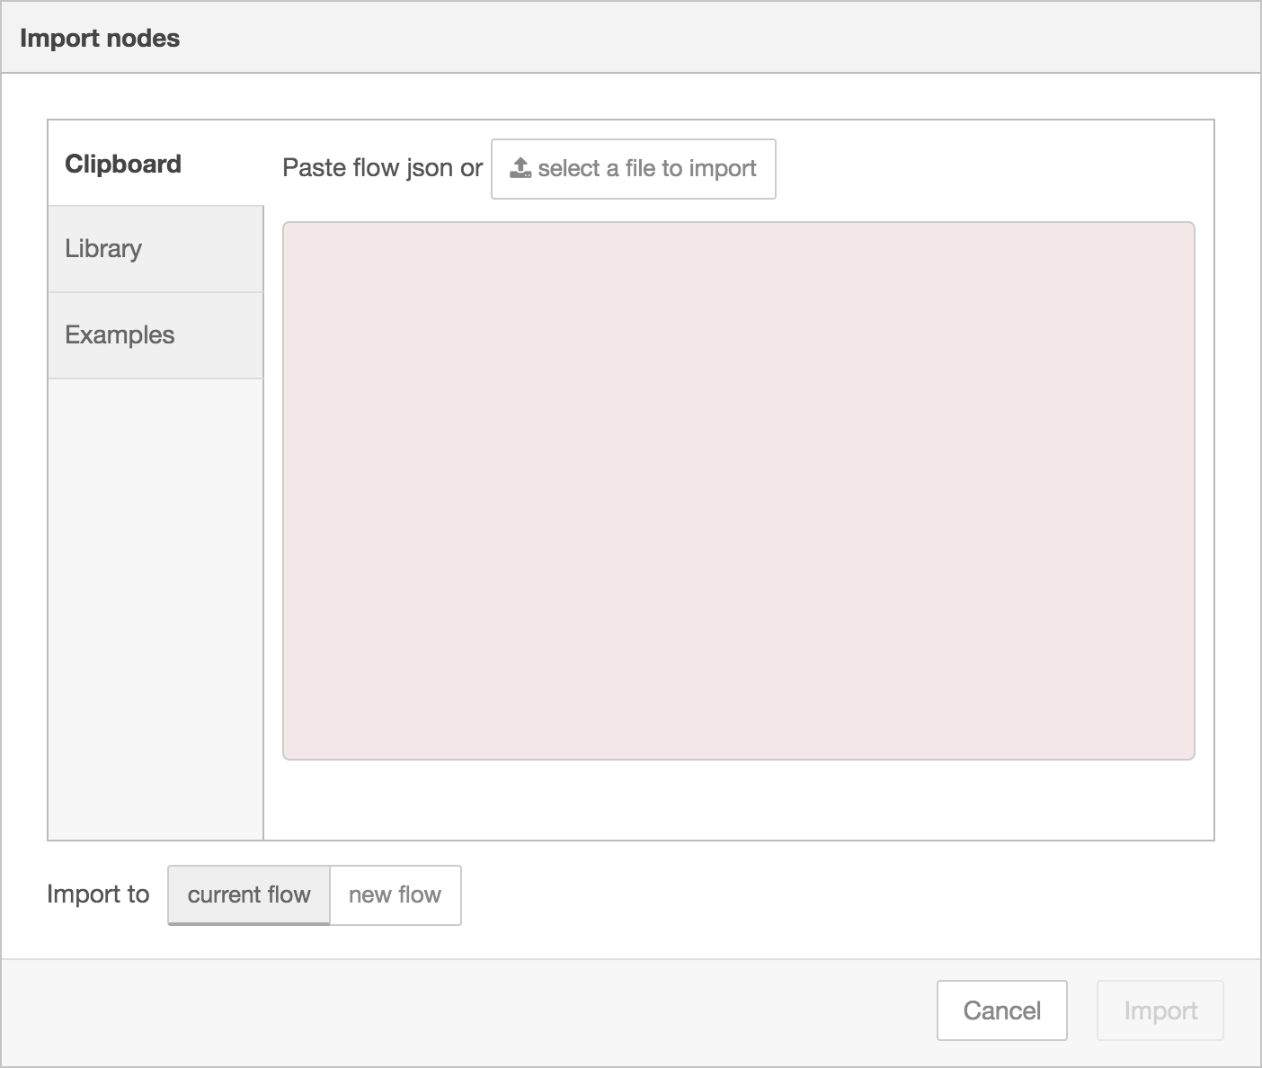
Import dialog
- pasting in the flow JSON directly,
- uploading a flow JSON file,
- browsing the local flow library,
- browsing the example flows provided by installed nodes.
In all cases, the dialog offers the option to import the nodes into the current flow, or to create a new flow for them.
Reference
Key shortcut | Ctrl/⌘-i
Menu option | Import
Action | core:show-import-dialog
Reference
Key shortcut | none
Menu option | none
Action | core:show-library-import-dialog
Reference
Key shortcut | none
Menu option | none
Action | core:show-examples-import-dialog

Exporting flows
The Export dialog can be used to copy flow json out of the editor by the following methods:
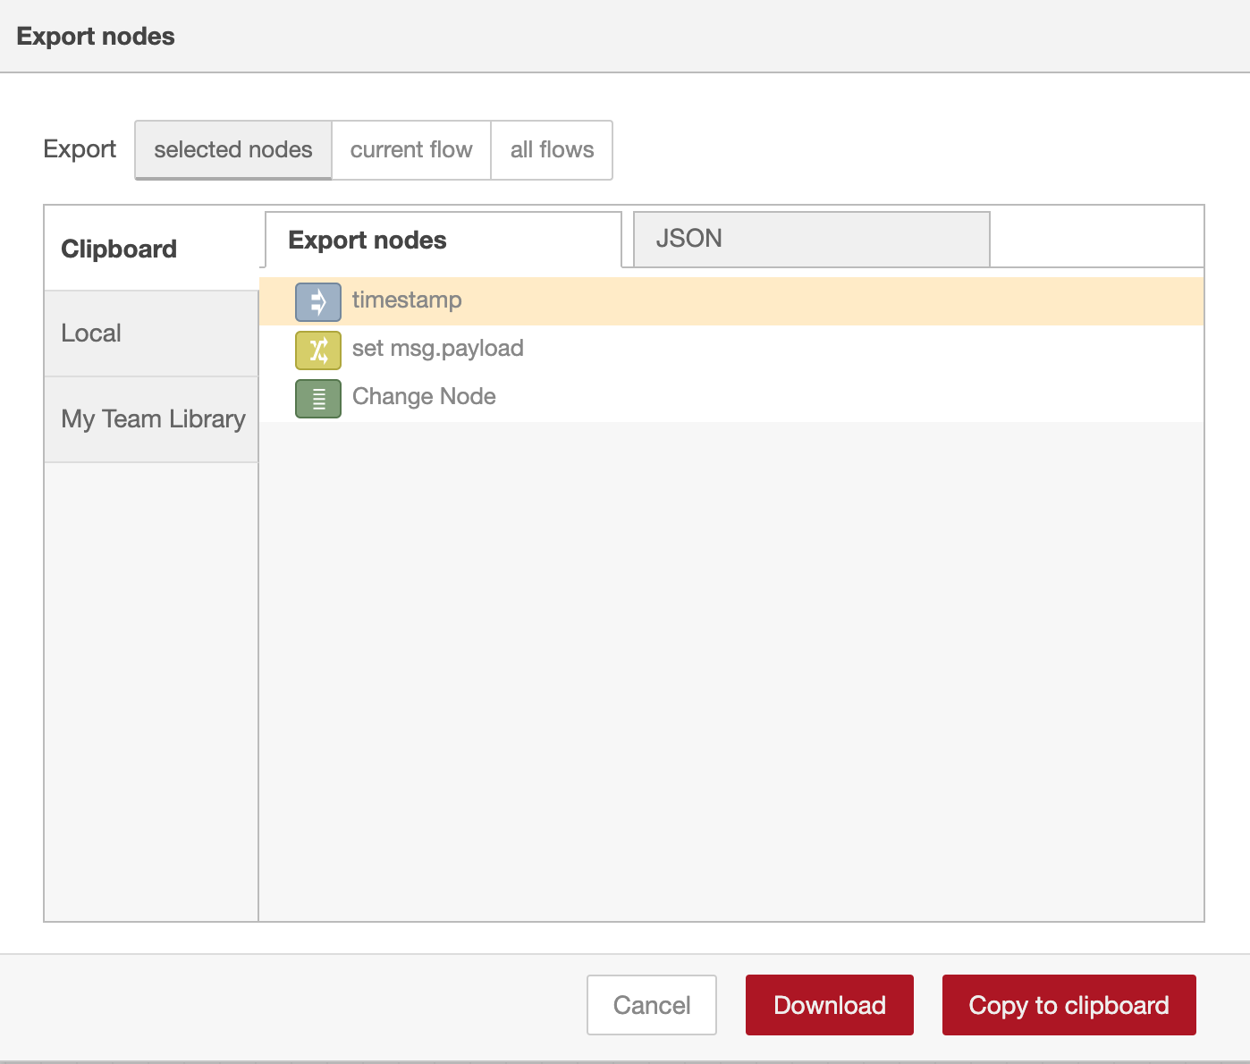
Export Flows dialog
- copying the JSON to the system clipboard,
- downloading the JSON as a file,
- saving it to the local flow library.
It can export either the selected nodes, the current flow (including its tab node) or the complete flow configuration.
It offers the option to export compact or formatted JSON. The compact option generates a single line of JSON with no whitespace. The formatted JSON option is formatted over multiple lines with full indentation - which can be easier to read.

Searching flows
The Search dialog can be used to find nodes within the workspace, including configuration nodes.
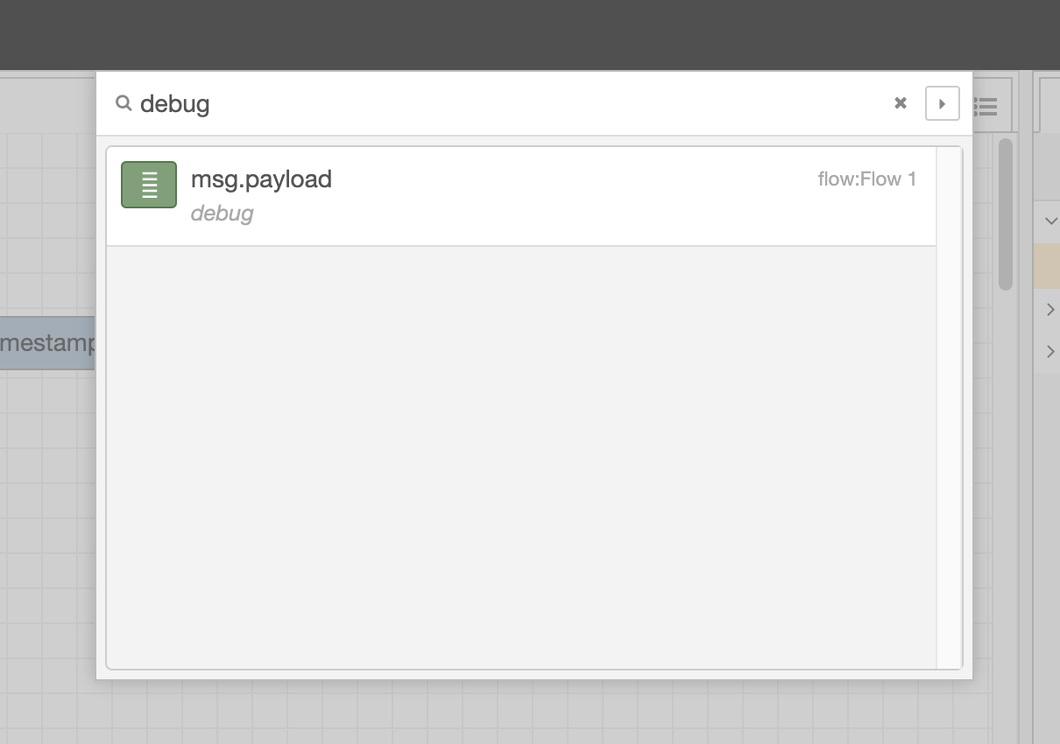
Search dialog
It indexes all properties of the nodes, so it can be used to search for a node by its id, type, name or any other property.
Selecting a node in the result list will reveal that node within the editor.
Clicking the button will copy the current search over to the Information sidebar search.
Reference
Key shortcut | Ctrl/⌘-f
Menu option | Search flows
Action | core:search

Search syntax
The search supports a number additional filters to help narrow down the results.

he palette contains all of the nodes that are installed and available to use.
They are organised into a number of categories, with inputs, outputs and functions at the top. If there are any subflows, they appear in a category at the top of the palette.
Categories can be expanded or collapsed by clicking its header.
The and buttons at the bottom of the palette can be used to collapse or expand all categories.
Above the palette is an input that can be used to filter the list of nodes.
The entire palette can be hidden by clicking the palette toggle that is shown when the mouse is over the palette.
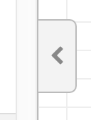
Palette toggle

The sidebar contains panels that provide a number of useful tools within the editor.
- Information - view information about nodes and their help
- Debug - view messages passed to Debug nodes
- Configuration Nodes - manage configuration nodes
- Context data - view the contents of context
Some nodes contribute their own sidebar panels, such as node-red-dashboard.
The panels are opened by clicking their icon in the header of the sidebar, or by selecting them in the drop-down list shown by clicking the button.
The sidebar can be resized by dragging its edge across the workspace.
If the edge is dragged close to the right-hand edge, the sidebar will be hidden. It can be shown again by selecting the
j

